MTIPL INC

##### A Project Report

Submitted in partial fulfillment of the Requirements for the award of the Degree of

### BACHELOR OF SCIENCE (INFORMATION TECHNOLOGY)

##### By

Rishiraj Shetty 123

**Under the esteemed guidance of Mrs. Firdous Khan Designation**



##### DEPARTMENT OF INFORMATION TECHNOLOGY

**MALINI KISHOR SANGHVI COLLEGE OF COMMERCE AND ECONOMICS**

***(Affiliated to University of Mumbai)* MUMBAI, 400049 MAHARASHTRA**

##### 2021-2022

**MALINI KISHOR SANGHVI COLLEGE OF COMMERCE ANDECONOMICS**

***(Affiliated to University of Mumbai)***

**MUMBAI-MAHARASHTRA-400049**

## DEPARTMENT OF INFORMATION TECHNOLOGY



**CERTIFICATE**

This is to certify that the project entitled, **"MTIPL INC "**, is bonafied work of **Rishiraj Shetty** bearing Seat.No: (**123**) submitted in partial fulfillment of the requirements for the award of degree of **BACHELOR OF SCIENCE in INFORMATION TECHNOLOGY** from University of Mumbai.

##### Internal Guide Coordinator

**External Examiner**

**Date: College Seal**

**PROFORMA FOR THE APPROVAL PROJECT PROPOSAL**

***(Note: All entries of the proforma of approval should be filled up with appropriate andcomplete information. Incomplete proforma of approval in any respect will be summarily rejected.)***

PNR **No.: 2019016402056982** Roll No**:** 123

1. Name of the Student Rishiraj Shetty
2. Title of the Project MTIPL INC
   1. Name of the Guide Mrs. Firdous Khan
3. Teaching experience of the Guide
4. Is this your first submission? Yes No

Signature of the Student Signature of the Guide

Date: ………………… Date: …………………….

Signature of the coordinator

# ABSTRACT

Our project is an online market place for laptops. This website which will help users to buy and rent, all types of computer and related hardware’s over the internet. This is an interactive website that allows users an opportunity to deal in new as well as used laptops. This feature makes it a unique and interesting one of its kind. The website has two basic modules. The first one is customer module and second one is admin module. Admin can change everything on the website and can update, add, delete any data; the customers have to register first. Registered customers can view all different types of hardware available to buy as well as rent the laptops through this website.

# ACKNOWLEDGEMENT

It is my pleasure to acknowledge you that I have received a project of Mtipl Inc from my teacher. My first sincere appreciation and gratitude goes to Mrs. Firdous Khan for her guidance, constructive feedback, valuable suggestions and inspirations. During making of my project she helped me a lot. All the work done in coming up with this system is dedicated to my family and friends for being with/part of me in the whole process especially my dear dad and mom who stood by me in all situations even at the times of financial need. Finally, I wish to say thanks to all Faculties of MKS for helping me a lot.

# DECLARATION

I hereby declare that the project entitled, “**Mtipl Inc**” done at **place where the project is done**, has not been in any case duplicated to submit to any other university for the award of any degree. To the best of my knowledge other than me, no one has submitted to any other university.

The project is done in partial fulfillment of the requirements for the award of degree of

**BACHELOR OF SCIENCE (INFORMATION TECHNOLOGY)** to be submitted as

final semester project as part of our curriculum.

##### Name and Signature of the Student

**TABLE OF CONTENTS**

|  |  |  |
| --- | --- | --- |
| **Sr. No.** | **Topics** | **Pg. No.** |
| **1** | **Introduction** | **10** |
| **1.1** | Background | **10** |
| **1.2** | Objectives | **11-13** |
| **1.3** | Purpose and scope | **13** |
| **1.3.1** | Purpose | **13-14** |
| **1.3.2** | Scope | **15** |
| **1.3.3** | Applicability | **15-16** |
|  |  |  |
| **2** | **System Analysis** | **19** |
| **2.1** | Existing System | **17** |
| **2.2** | Proposed System | **17** |
| **2.3** | Requirement Analysis | **17** |
| **2.4** | Hardware Requirements | **18** |
| **2.5** | Software Requirements | **18** |
| **2.6** | Justification of selection of  Technology | **18** |
| **2.7** | Technologies used | **19-20** |
|  |  |  |
| **3** | **System Design** | **21** |
| **3.1** | Problem definition | **21** |
| **3.2** | Requirements Specification | **21** |
| **3.3** | Planning and Scheduling | **22-23** |
| **3.4** | Development Scheduling | **23-24** |
| **3.5** | Preliminary Product  Description | **24** |

|  |  |  |
| --- | --- | --- |
| **3.6** | Conceptual Model | **24** |
|  |  |  |
| **4** | **Implementation and**  **Testing** | **25** |
| **4.1** | Basic Models | **25** |
| **4.2** | Data Design | **26** |
| **4.3.1** | Logic Diagrams | **26** |
| **4.3.2** | Data Structures (MVT  DATA STRUCTURE) | **27** |
| **4.3.3** | Algorithms Design | **28** |
| **4.4** | Security Issues | **29** |
| **4.5** | Test Cases Design | **30-31** |
|  |  |  |
| **5** | **Implementation and**  **Testing** | **32** |
| **5.1** | Implementation Approaches | **32** |
| **5.2** | Coding Details and Coding  Efficiency | **32-33** |
| **5.2.1** | Code Efficiency | **33** |
| **5.3** | Testing Approach | **33-34** |
| **5.4** | Modifications and  Improvements | **34-35** |
| **5.5** | Test Cases | **35-40** |
|  |  |  |
| **6** | **Result and Discussion** | **41** |
| **6.1** | Test Result | **41-45** |
| **6.2** | User Documentation | **46** |
|  |  |  |

|  |  |  |
| --- | --- | --- |
| **7** | **Conclusions** | **47** |
| **7.1** | Conclusion | **47** |
| **7.1.1** | Significance of the system | **48** |
| **7.2** | Limitations of the system | **49** |
| **7.3** | Future scope of the project | **49** |

**Chapter 1 Introduction**

* 1. **Background**
     1. In a country with the population over 1.3 billion people education is an integral part of the society, to keep learning and developing themselves and helping our environment, economy, society and making our social life sustainable.
     2. This Website is an interactive solution providing users with an opportunity to buy and rent laptops or related hardware online. It is a platform where users can deal in new and old laptops or related hardware.
     3. We aim to deliver a constructive service to users by creating an online platform where professionals and gamers can get their desired laptops and their accessories just a few taps away.
     4. By Ecommerce, we mean buying and selling of products or services over electronic systems such as the Internet and other computer networks
     5. E-commerce is fast gaining ground as an accepted and used business paradigm. More and more business houses are implementing web sites providing functionality for performing commercial transactions over the web. It is reasonable to say that the process of shopping on the web is becoming commonplace.
  2. **Objectives**

Online Market Place and E-Commerce Websites with Their Exponential Growth have taken over the market in little over a decade.

The Objective of this particular marketplace include providing the users with a place where they can buy and rent laptops online with relative ease as compared to hassles of doing it over the laptop shop.

1. Reduce management costs

Businesses aim at reducing the costs incurred for the betterment of their revenue. Automating the ecommerce business can help in reducing the management cost significantly. Moreover, the right use of digital marketing can help in reducing the cost spent on driving customers to such an extent that businesses can bring customers for free of cost.

1. Developing business relations

With ecommerce as the primary use, business development can be easily achieved. The direct communication between a company and the customer, the business relationship can be boosted. Eventually, the ecommerce market shall be expanded.

1. Providing a unique customer experience

There are probably hundreds or thousands of e-commerce and online marketplace websites out on the internet. Most of them provide many types of functionalities but with this particular marketplace we aim to provide a niche market for laptops where users can not only buy Refurbished and new laptops but also rent them opening up a new possibility for money making through internet.

1. Increasing the number of loyal customers

Customers are the core of all business strategies. Therefore, ensuring the great customer experience is of prime importance for the growth of the business. You need to meet your customers where they spend their time. More than 60% of consumers look for purchasing goods and services online. If you meet your customers where they are already active, the chances of them, interacting with your business increases two folds. You can increase the number of loyal customers by giving the best experience to your already existing customers as well as bring in newer customers.

1. Boosting the efficiency of services

With the continually evolving technology, you need to enhance the efficiency of your services. By choosing an online ecommerce platform to create an online store, you can efficiently reduce the cost of managing and renting online. This marketplace provides a whole new experience of online laptop shopping to users through the help of good customer services and reduced delivery time.

Another way is to provide your customers with automated services such as status update, invoice creating, chat support, etc. You can witness happy customers which in turn can boost your revenue and help you create a strong online presence.

1. Developing relevant target

Developing relevant traffic for an ecommerce business is a common objective. Whether an ecommerce website or an online store, building traffic is one of the most important objectives. To boost your traffic, you need to target specific audience who can find your online marketplace relevant to their needs. This relevancy can be achieved through collection of customer data and inclusion demographics such as age, location, sex, interests, browsing data, browsing history, etc.

### Purpose and Scope

* + 1. **Purpose**

The goal of this project is to create a web application that shows laptops, desktops, monitors, peripherals and online enquiry in an e-commerce website. Customer will register and book on this site. By entering his login details. The key operator of this system is that one can look at options online.

There are plenty of purposes of a website, most of which can be confined to one goal, earning profits. An ecommerce or marketplace website implies a virtual store where visitors come to the store, pick the products of choice, and become customers by purchasing the product

The purpose of our website is:

* + - 1. To provide customers with a place where they can find any computer hardware as per their requirement at mere search away.
      2. Building a beautiful and responsive website that can attract user’s attention.
      3. Providing users with an interactive and modern website that can offer them many technologies which can ease things for them like chat box, etc.
      4. Making users feel safe with a secure and safe website which provide secure and trustworthy transactions.
      5. Providing users with a website free of scammers with the admins continuously

monitoring the user’s data for spam, scam and bots.

* + - 1. Providing Users with a wide range of customers and sellers from all over the country.
      2. Taking User Feedbacks for improvisation of services.
      3. Providing the means of interaction between buyer and seller.
      4. Providing The Users with genuine details of the products.
      5. It saves considerable time for the consumers; no endless walking to find products, No Overpaying for The products.
      6. Consumers can purchase online from anywhere at any time using this website.
      7. Addition of unlimited products to the website and categorizing them to sell efficiently.
      8. Creating the brand authenticity and gaining trust of the customers.
      9. Providing users with genuine product at a fair price.

### Scope

Now a day, marketplaces are in high demand, because anyone at any time can buy and rent the desired products with only a few taps over their mobile phones.

The market of computer hardware particularly laptops is a huge market. And almost next to none marketplace provide a niche market for laptops.

With the creation of marketplace from which users can buy and rent laptops few taps away and saving them the hassle of running to multiple hardware shops can create a huge opportunity for this website.

Easily methods and communication and availability of services round the clock can satisfy customer demands and help with growth of the services.

With the help of secure, safe and genuine services you can save yourselves from scams done by owners.

The services like renting and buying of refurbished laptops can help users get laptops in affordable price as compared to sky rocketing price asked by bookshop owners

While users can also make money by renting laptops which would have been discarded otherwise.

As we all are aware that there are lot of restrictions imposed by the Central/State/Local Government bodies due to Covid19 pandemic.

So this website will help the user to order laptops or related hardware items from their houses,

lowering their risk from being infected by Covid’19

### Applicability

The benefits of laptops can be applied in each and every field of life.

With the presence of an online store it just makes things easier for everyone.

While there are tons of websites on internet which provide online stores for buying electronic and some provide places to sell only a handful provide good enough service and a place to both buy and rent laptops.

But with the development of this interactive website not only will users get great services to buy and rent laptops but will also find a community for them where they can get all the desired laptops and services.

The web app has a fully responsive layout for mobile and desktop screens. All the user has to do is set up their profile by following the simple instructions on the sign up page and add items to the cart and end with checkout.

# Chapter 2 Survey of Technologies

## Existing System:

Right now, there are no online marketplaces that provide a niche market only focused with laptops and related hardware’s. Although there are many online laptop shops and that do provide laptops. And there are also a few market place apps that also provide laptop selling and buying services along with many other products, but because of lack of delivery services or expensive delivery services these marketplaces become not so viable options for laptop selling and buying. Also these market places make majority of their income through other sale of other services whereas laptops make up a small margin of it. The online shops also charge hefty charges for laptops and additional delivery charges which can be expensive buy for academic students.

Also, a very few number of these system provide Refurbished laptops.

## Proposed System

The Proposed system provides a whole new level of choices and services to users. Users can get any laptop of their choice new as well as Refurbished laptops. This system also provides a platform for small scale hardware vendors to go online and makes sales and increase their range and presence while making profits online. Students can also make profit off of their used laptops by selling or renting them online through our system something which in not provided by many other systems.

## Requirement Analysis

We aim to provide users with best services by using best available technologies and resources at lowest requirement so we can reach out to as many users as possible.

After analyzing the system, the software and hardware requirements of optimally running the services has been identified.

## Hardware Requirements

* + 1. Processor: Pentium, AMD, or Higher Version. 2.4.2) Operating System: Windows XP/ Windows 7/ Linux
    2. RAM: 256 MB, 2GB recommended
    3. Hardware Devices: Keyboard with mouse 2.4.5) Hard disk: 10GB or More

## Software Requirements

* + 1. Technology Implemented: GCP Server (Firebase)
    2. Language Used: Node JS
    3. User Interface Design: React JS
    4. Web Browser: Cross Browser Compatibility (Chrome, Firefox, Safari etc.)

## Justification Of Platform

The afore mentioned software and hardware’s required are very basic and can be supported by any modern-day laptops and phones.

The hardware and software requirements are minimum that is used by a modern web browser and that support the technologies used by modern browsers. With the help of these basic functionalities users can use all functionalities and services of the website in all its glory.

## Technologies Used

A lot of technologies were used for the production of this website based on their efficiency and benefits of functionalities they provide:

The technologies are as follows:

### Front End Technologies:

##### NodeJS:

Node.js is an open source server environment Node.js is free

Node.js runs on various platforms (Windows, Linux, UNIX, Mac OS X, etc.) Node.js uses JavaScript on the server

Node.js can create, open, read, write, delete, and close files on the server Node.js can collect form data

Node.js can add, delete, modify data in your database

### JavaScript

JavaScript is the world's most popular programming language. JavaScript is the programming language of the Web.

JavaScript is easy to learn.

It is used to program the behaviour of web pages.

## Backend:

### 1) Mongo DB

Mongo DB is an open-source document database and leading NoSQL database. Mongo DB is written in C++.

It is needed to create and deploy a highly scalable and performance-oriented database.

Mongo DB is a cross-platform, document oriented database that provides, high performance, high availability, and easy scalability. Mongo DB works on concept of collection and document. Database is a physical container for collections. Each database gets its own set of files on the file system. A single Mongo DB server typically has multiple databases.

Collection is a group of Mongo DB documents. It is the equivalent of an RDBMS table. A collection exists within a single database. Collections do not enforce a schema. Documents within a collection can have different fields. Typically, all documents in a collection are of similar or related purpose.

A document is a set of key-value pairs. Documents have dynamic schema. Dynamic schema means that documents in the same collection do not need to have the same set of fields or structure, and common fields in a collection's documents may hold different types of data.

### Web Service: GCB Server

We would be using this for hosting our frontend on the internet. Google Cloud Platform (GCP),

offered by Google, is a suite of cloud computing services that runs on the same infrastructure that Google uses internally for its end-user products, such as Google Search, Gmail, GoogleDrive and YouTube.

# Chapter 3 Requirement And Analysis

## Problem Definition

An E-commerce store aims to develop an online shopping for customers with the goal to provide easy way to shop your loved things from an extensive number of online shopping sites available on the web. With the help of this you can purchase anything from your home. Here is no compelling reason to go to the crowded stores or shopping centers during festival seasons. You simply require a PC or a laptop and one important payment sending option to shop online. However, there is a lot of competition among multiple e- commerce sites. When users land on an e-commerce site, they expect to find what they are looking for quickly and easily. Also, users are not sure about the brands or the actual products they want to purchase. They have a very broad idea about what they want to buy. Many customers nowadays search for their products on Google rather than visiting specific e-commerce sites.

They believe that Google will take them to the e-commerce sites that have their product. I believe, this Online E-commerce Hardware services platform, will help cater to all Hardware and technology related queries and issues.

## Requirements Specification

#### SOFTWARE SPECIFICATION:

* + - Technology Implemented: GCP Server (Firebase)
    - Language used: Node JS
    - Database: My SQL, Mongo DB User Interface Design: React JS
    - Web Browser: Cross Browser Compatibility (Chrome, Firefox, Safari etc.)

#### HARDWARE SPECIFICATION:

* + - Processor: Pentium, AMD, or Higher Version.
    - Operating System: Windows XP/ Windows 7/ Linux
    - RAM: 256 MB, 2GB recommended
    - Hardware Devices: Keyboard with mouse
    - Hard disk: 10GB or More

## Planning And Scheduling

##### Gantt chart:

A Gantt chart, commonly used in project management, is one of the most popular and useful Ways of showing activities (tasks or events) displayed against time. On the left of the chart is a List of the activities and along the top is a suitable time scale. Each activity is represented by a Bar; the position and length of the bar reflects the start date, duration and end date of the activity. A Gantt chart is constructed with a horizontal axis representing the total time span of the project, Broken down into increments (for example, days, weeks, or months) and a vertical axis Representing the tasks that make up the project (for example, if the project is outfitting your Computer with new software, the major tasks involved might be: conduct research, choose Software, install software). Horizontal bars of varying lengths represent the sequences, timing, And time span for each task. Using the same example, you would put "conduct research" at the Top of the vertical axis and draw a bar on the graph that represents the amount of time you expect To spend on the research, and then enter the other tasks below the first one and representative Bars at the points in time when you expect to undertake them. The bar spans may overlap, as, for Example, you may conduct research and choose software during the same time span. As the Project progresses, secondary bars, arrowheads, or darkened bars may be added to indicate Completed tasks, or the portions of tasks that have been completed. A vertical line is used to represent the report date.

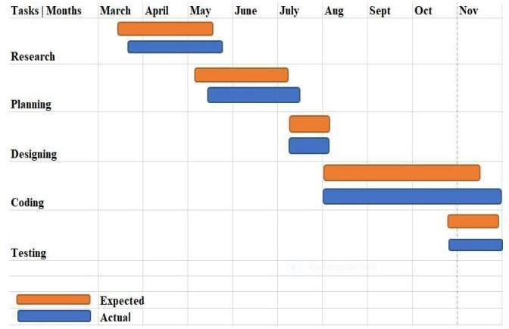

##### Stages of project scheduling are:

1. Based on the project scope, design and develop the TBS (Task-Breakdown Structure).
2. Identify the project-related tasks.
3. Identify the human resources and material requisite
4. Evaluate the approximate time required for each and every task
5. Allocation of resources
6. Analyse the detailed schedule
7. Monitor and govern the schedule

## Development Schedule

The work in developing the new system commented immediately with our first meeting with the management and users thereafter were in continuous touch with the management and users of the company. **Phases Involved in the development of the system**

Identify needs and benefits

* Held meetings with the management and user
* Studied and identified the existing system.
* Identify needs and project constraints
* Established project statements
* Prepared a detailed report of the existing system at work.
* Actual coding started

### Preliminary Product Description

This aim of the project is to create a website that can be used by technology lovers to Buy/Rent their Laptops online.

### Conceptual Model

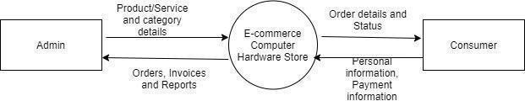

**Chapter 4 SYSTEM DESIGN**

* 1. **Basic Modules**

1. ADMIN PAGE-
   * Admin can view all consumer data.
   * Admin can edit profile details.
   * Admin can login into this system.
   * Admin can see Analytics data.
   * Admin can update the product.
2. CONSUMERS PAGE:
   * Consumer can login and register.
   * Consumer can search the product and add to cart.
   * Consumer can pay for the order using debit and credit card.

### Data Design

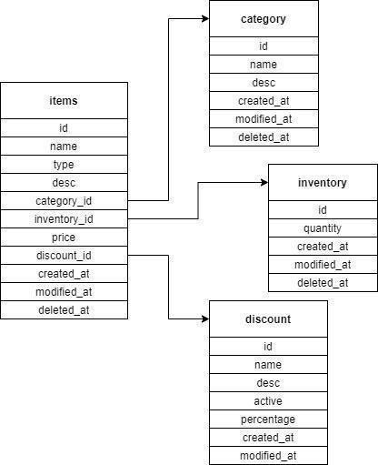

* + 1. **Logic Diagrams**

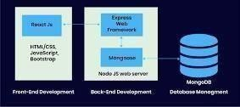

* + 1. **Data Structures (MVT DATA STRUCTURE)**

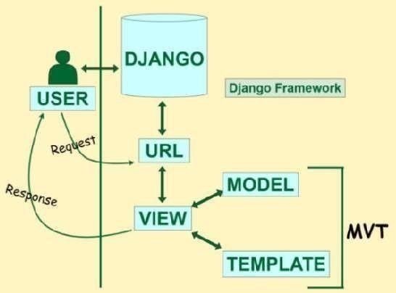

* + 1. **Algorithms Design**

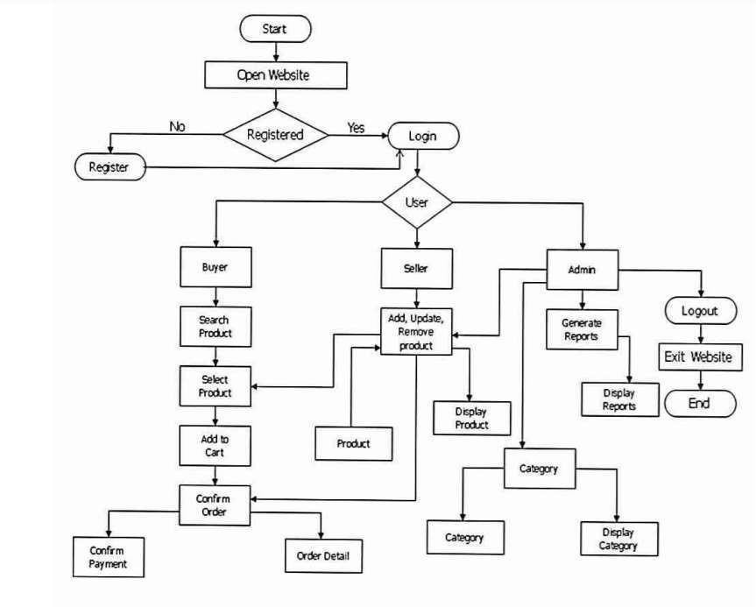

* 1. **Security Issues**
* **Spamming**:

Some bad players can send infected links via email or social media inboxes. They can also leave these links in their comments or messages on blog posts and contact forms.

### DoS & DDoS Attacks:

Many e-commerce websites have incurred losses due to disruptions in their website and overall sales because of attacks. What happens is that your servers receive a deluge of requests from many untraceable IP addresses causing it to crash and making unavailable to your store visitors?

### Malware:

Hackers may design a malicious software and install on your IT and computer systems without your knowledge. These malicious programs include spyware, viruses, Trojan, and ransom ware.

### FINANCIAL FRAUD:

Ever since the first online businesses entered the world of the internet, financial fraudsters have been giving businesses a headache. There are various kinds of financial frauds prevalent in the e-commerce industry, but we are going to discuss the two most common of them.

### Credit Card Fraud

It happens when a cybercriminal uses stolen credit card data to buy products on your e- commerce store. Usually, in such cases, the shipping and billing addresses vary. You can detect and curb such activities on your store by installing an AVS – Address Verification System.

Another form of credit card fraud is when the fraudster steals your personal details and identity to enable them to get a new credit card.

### Fake Return & Refund Fraud

The bad perform unauthorized transactions and clear the trail, causing businesses great losses. Some hackers also engage in refund frauds, where they file fake requests for returns

### Test Cases Design

#### DFD DIAGRAM:

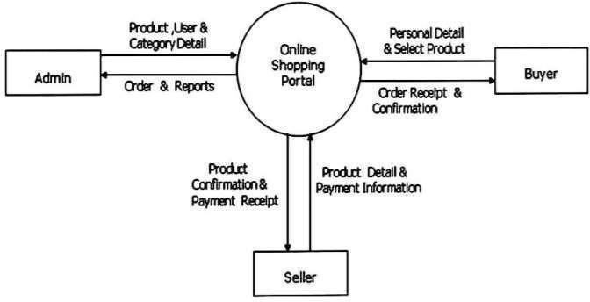

* USE CASE DIAGRAM:

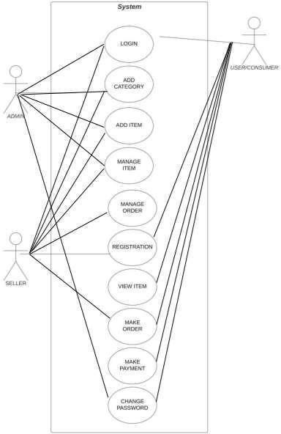

**Chapter 5 Implementation and Testing**

* 1. **Implementation Approaches**

Implementation: - Once source code has been generated, software must be tested to uncover (and correct) as many errors as possible before delivery to customer. Our goal is to design a series of test cases that have a high likelihood of finding errors. To uncover the errors software techniques are used. These techniques provide systematic guidance for designing test that exercise the internal logic of software components, and exercise the input and output domains of the program to uncover errors in program function, behaviour and performance.

Steps:

* + - Software is tested from two different perspectives:

Internal program logic is exercised using ―White box‖ test case design techniques.

* + - Software requirements are exercised using ―black box‖ test case

Design techniques. In both cases, the intent is to find the maximum number of errors with the minimum amount of effort and time.

Mtipl Inc: Ecommerce hardware store

## Coding Details And Efficiency

5.2.1 **Coding Efficiency**

Code efficiency is a broad term used to depict the reliability, speed and programming methodology Used in developing codes for an application. Code efficiency is directly linked with algorithmic Efficiency and the speed of runtime execution for software. It is the key element in ensuring high Performance. The goal of code efficiency is to reduce resource consumption and completion time as much as possible with minimum risk to the business or operating environment. The software product quality can be accessed and evaluated with the help of the efficiency of the code used removed unnecessary code or code that goes to redundant processing used of optimal memory and Non- volatile storage ensured the best speed or run time for completing the algorithm use of reusable components wherever possible have use of error and exception handling at all layers of software,

such as the user interface, logic and data flow created programming code that ensures data integrity and consistency developed programming code that's compliant with the design logic and flow have use of coding practices applicable to the related software optimized the use of data access and data management practices used best keywords, data types and variables, and other available programming concepts to implement the related algorithm.

## Testing Approach

A strategy for software testing must accommodate low-level tests that are necessary to verify that a small source code segment has been correctly implemented as well as high-level tests that validate major system functions against user requirements. A strategy must provide guidance for the practitioner and a set of milestones for the manager. Because the steps of the test strategy occur at a time when deadline. Pressure begins to rise; progress must be measurable and problems must surface as early as possible. Following testing techniques are well known and the same strategy is adopted during this project testing.

## Unit Testing

Unit testing focuses verification effort on the smallest unit of software design-the software component or module. The unit test is white-box oriented. The unit testing is implemented in every module of mtipl manager by giving correct manual input to the system, the data are stored in database and retrieved. If user wants a required module to access the input or get the output from the end user. In this method of testing that verifies the individual units of source code are working properly. The goal of unit testing is to isolate each part of the program and show that the individual parts are correct. The Unit a testing tool for Java will be used for unit testing.

## Integration Testing

Integrated testing we are to check that once we login, place the order and logout. Then we login again to see if our order is still there and if it is counted.

## Beta Testing

Beta Testing is performed by real users of the software application in a real environment. Beta testing is one of the types of User Acceptance Testing.

Beta version of the software, whose feedback is needed, is released to a limited number of end-users of the product to obtain feedback on the product quality. Beta testing helps in minimization of product failure risks and it provides increased quality of the product through customer validation.

It is the last test before shipping a product to the customers. One of the major advantages of beta testing is direct feedback from customers.

## Modification And Improvements

The sheer volume of e-commerce websites out there means that you need to have a highly-customised and effective website to make an impact. To help you make your website pop and sparkle, here are four things you should look into about your e-commerce website.

## Improve Customer Service

Discounts, free delivery & coupons are great ways to attract customers, but they don’t affect retention in the long term. Customer service is proven to be a deciding factor for long term customer retention with 86 percent customers reportedly willing to pay up to 25 percent more for better customer experience.

Companies with good customer service will be rewarded with improved consumer lifetime value and transaction size. Your ecommerce website needs to be designed in a way, wherein all the information they need should be clearly visible.

Make sure that your contact information (email and telephone numbers) are visible on each page of your ecommerce website. This gives your customers the option to contact you if they have queries or issues they need to resolve.

When customers submit a ticket or call your service number, ensure that you’re well-prepared to manage issues promptly and solve them in a timely manner. Any delay in problem resolution will cause negative feedback, which can deter customers from using your services in the future.

## Make Website Decisions for Search Engine Optimization

Search Engine Optimization (SEO) refers to the process of taking steps to drive more traffic to your website from known search engines. To make your e-commerce website more SEO friendly, ensure that your website is easily accessible, you have an active blog with content updated regularly, and you’re using accurate keyword and descriptions that attract customers and optimize your webpage for search engines.

Use website traffic analysis tools such as Google Analytics, SEMrush etc., to identify reasons that makes visitors switch from your site to the website of your competitor.

Based on what you find, make relevant changes, try A/B testing on different templates & features, and implement methods that proves to be successful in converting visitors to customers.

## Create & Use Quality Product Images & Description

Use good quality images for all your listed products. After all, you want to give customers a great buying experience, which includes making their purchase experience as like buying at a physical store.

Additionally, focus on writing high-quality product descriptions. Product descriptions help customers

understand the relevance of a product and how it’s a solution to their pain points.

## Build Customer Loyalty Using Email Marketing

Email marketing is a great way to find new leads & convert them to customers. Use email blasts to communicate sales, discounts, offers and content to subscribers not present on your other marketing channels.

Incorporate different types of emails to communicate a healthy variety of promotions, updates, news, industry content, etc. A strong email list is important for continued growth, because emails are the easiest channel to convert subscribers into customers.

Making checkout simpler, navigation simpler, including mobile compatibility and customer reviews, are the four ways with which you can take your e-commerce website from 9 to 99. These are quite simple to initiate on your website, but their impact will be deep-seated and will yield returns in customer retention and purchases.

## TEST CASES

Test case is an object for execution for other modules in the architecture does not represent any interaction by itself. A test case is a set of sequential steps to execute a test operating on a set of predefined inputs to produce certain expected outputs. There are two types of test cases: - manual and automated. A manual test case is executed manually while an automated test case is executed using automation. In system testing, test data should cover the possible values of each parameter based on the requirements. Since testing every value is impractical, a few values should be chosen from each equivalence class. An equivalence class is a set of values that should all

be treated the same. Ideally, test cases that check error conditions are written separately from the functional test cases and should have steps to verify the error messages and logs. Realistically, if functional test cases are not yet written, it is ok for testers to check for error conditions when performing normal functional test cases. It should be clear which test data, if any is expected to trigger errors.

|  |  |  |  |  |  |  |  |
| --- | --- | --- | --- | --- | --- | --- | --- |
| Test Case Id | Test Case | | Expected Result | | | Actual Result | |
| 1 | User Registration | | User should be able to register himself His name email id and password should be validated. | | | User was able to register himself. All client side validation was taken care. | |
| 2 | Login with correct user name and password | | User should be successfully login to account. | | | User was able to login successfully | |
| 3 | User Login with incorrect username and password | | User should be not allowed to login and application must display “Incorrect  Login Details” | | | Application displayed  “Please add valid email address” and user was not allow to login | |
| 4 | Login with admin name and password | correct | Admin successfully account. | should  login | be to | Admin was able to login successfully | |
| 5 | Admin Login with incorrect username and password | | Admin should be not allowed to login and error massage shows | | | Admin was not able to login. | |
| 6 | Add candidates with valid information | | Candidates should add  successfully | | | Candidates was  successfully | added |

##### Home page

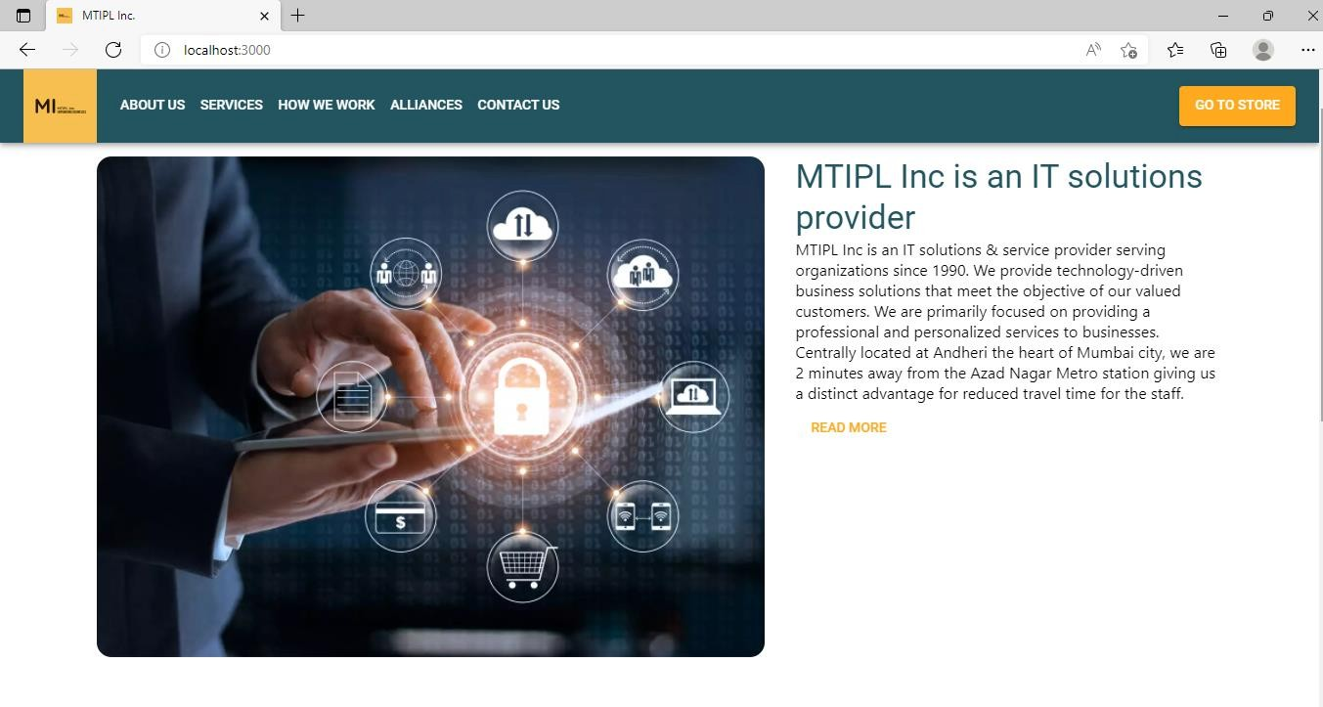

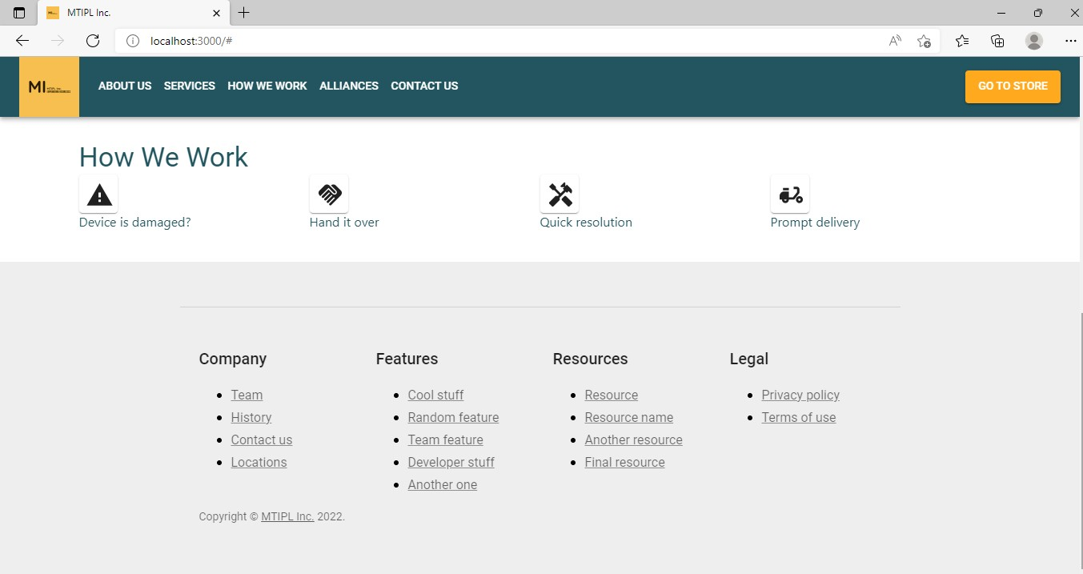

import { BrowserRouter,

Routes, Route,

} from "react-router-dom";

import { ThemeProvider, createTheme } from '@mui/material/styles';

import './App.css';

import ResponsiveAppBar from './components/NavBar'; import SignIn from "./pages/SignIn";

import SignUp from "./pages/SignUp"; import HomePage from "./pages/HomePage"; import Store from "./pages/Store"; import Checkout from "./pages/Checkout";

import ProductPage from "./pages/ProductPage"; import StickyFooter from "./components/StickyFooter"; import { Box } from "@mui/material";

import { AuthContext } from "./utils/context/auth-context"; import { useAuth } from "./utils/hooks/auth-hook";

import OrderSuccessful from "./pages/OrderSuccessful";

const theme = createTheme({ typography: {

fontFamily: [ 'Roboto', '"Helvetica Neue"', 'Arial',

'sans-serif'

].join(','),

},

palette: { primary: {

light: '#40A0B5', main: "#225560", dark: "#16363C",

contrastText: "#fff"

},

secondary: { light: '#FFC870', main: '#FFA91F', dark: '#CC7E00',

contrastText: '#000'

}

}

});

function App() {

const { token, login, logout , userId } = useAuth();

return (

<ThemeProvider theme={theme}>

<AuthContext.Provider value={{

isLoggedIn: !!token, token: token, userId: userId, login: login, logout: logout

}}

>

<BrowserRouter>

<Box

sx={{

display: 'flex', flexDirection: 'column', minHeight: '100vh',

}}

>

<ResponsiveAppBar />

<Routes>

<Route index element={<HomePage />} />

<Route path="/login" element={<SignIn />} />

<Route path="/signup" element={<SignUp />} />

<Route path="/store" element={<Store />} />

<Route path="/product" element={<ProductPage />} />

<Route path="/checkout" element={<Checkout />} />

<Route path="/order/success" element={<OrderSuccessful />} />

</Routes>

<StickyFooter />

</Box>

</BrowserRouter>

</AuthContext.Provider>

</ThemeProvider>

);

}

export default App;

**Object Oriented**

This approach does produce well-designed, working systems, the current opinion among many practitioners is that the resulting systems tend to be rigid and make it difficult to respond quickly to changes in user requirements. Unlike its two predecessors; the object-oriented approach combines data and processes into single entities called objects. Objects usually correspond to the real things a system deals with, such as customers, suppliers, contracts, and invoices. Object-oriented models are able to thoroughly represent

complex relationships and to represent data and data processing with a reliable notation, which allows an easier mix of analysis and design in a growth process. The aim of the Object-Oriented approach is to make system elements more modular, thus improving system quality and the efficiency of systems analysis and design.

## Test Case Design

Testing Mtipl Inc. website requires knowledge of web testing techniques and the

E-commerce domain. Most ecommerce websites share a general common theme and structure. Features to be tested

The following list describes the features to be tested: USER:

Registration Login

Add To Cart Edit Cart

ADMIN:

Create and Delete item from Category Create and Delete a Category

Manage Orders Manage Members

### Test Reports

**CHAPTER 6**

**Results And Discussions**

Here is the sign up page. One has to make an account to purchase an order.

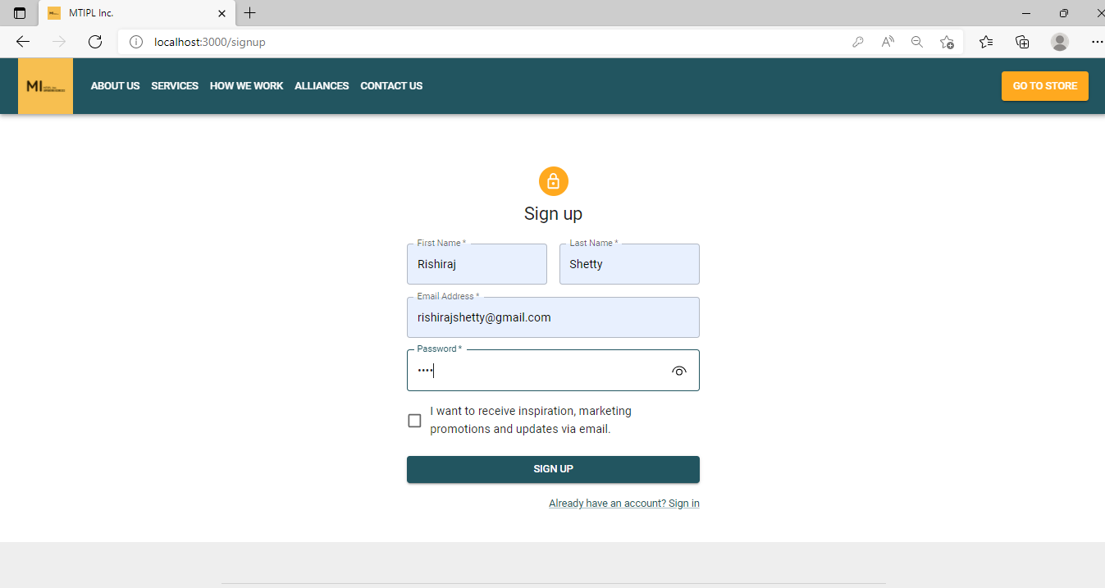

If the user already has an account it would show as an error.

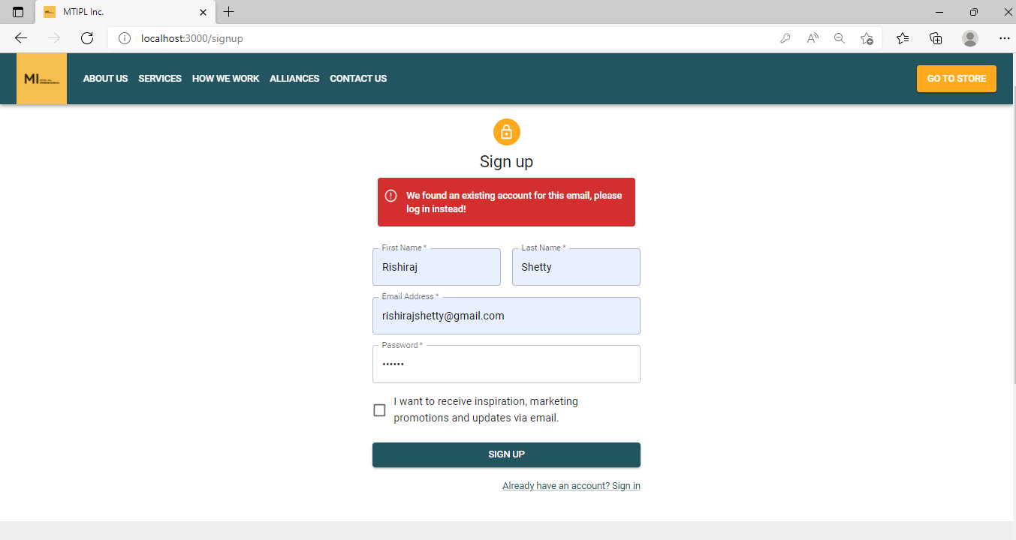

A valid email id needs to be entered.

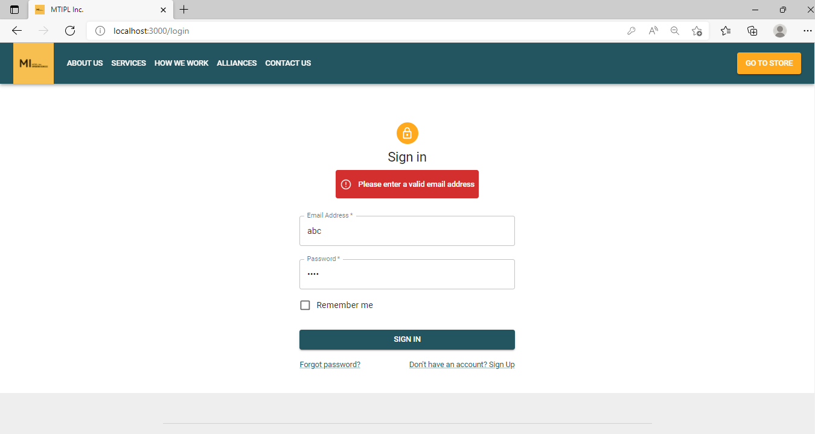

To proceed with the order, there are 3 steps:

* + 1. Shipping Address
    2. Payment details
    3. Review your order

A valid card name, card number, expiry date and CVV have to be entered.

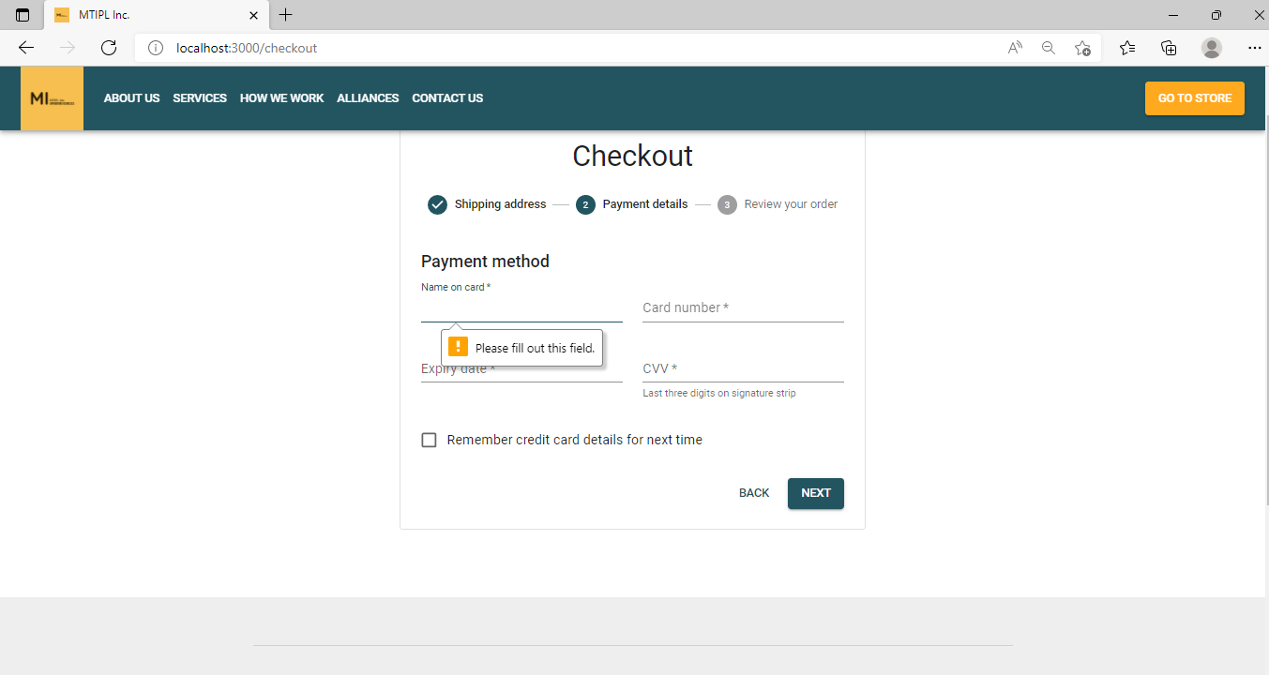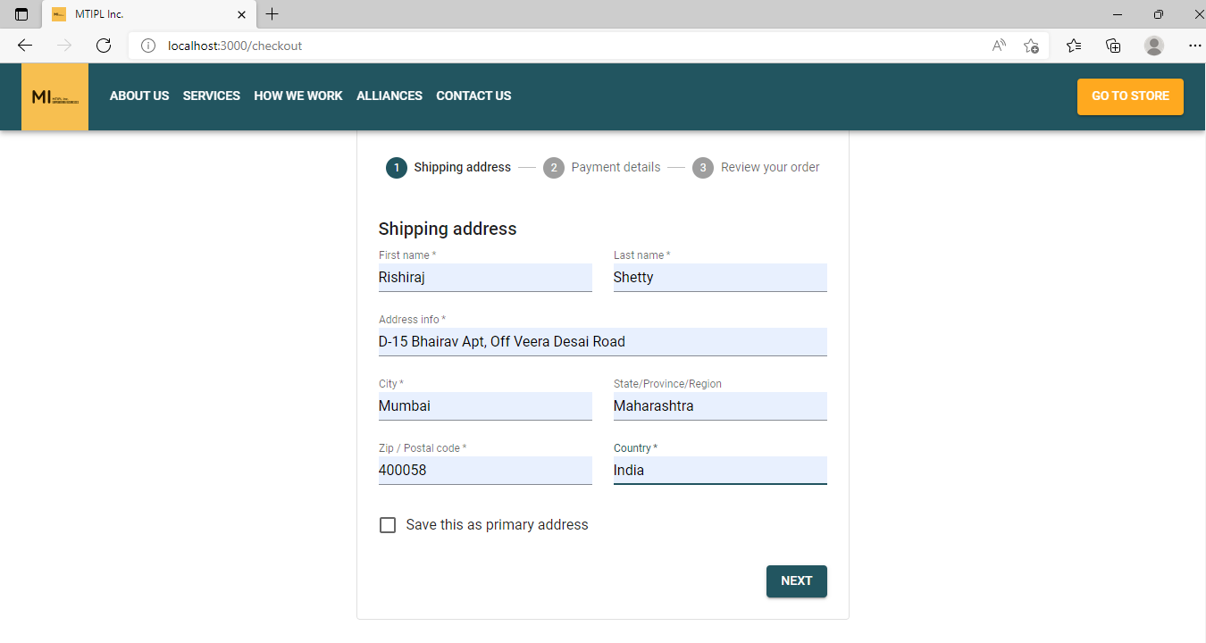

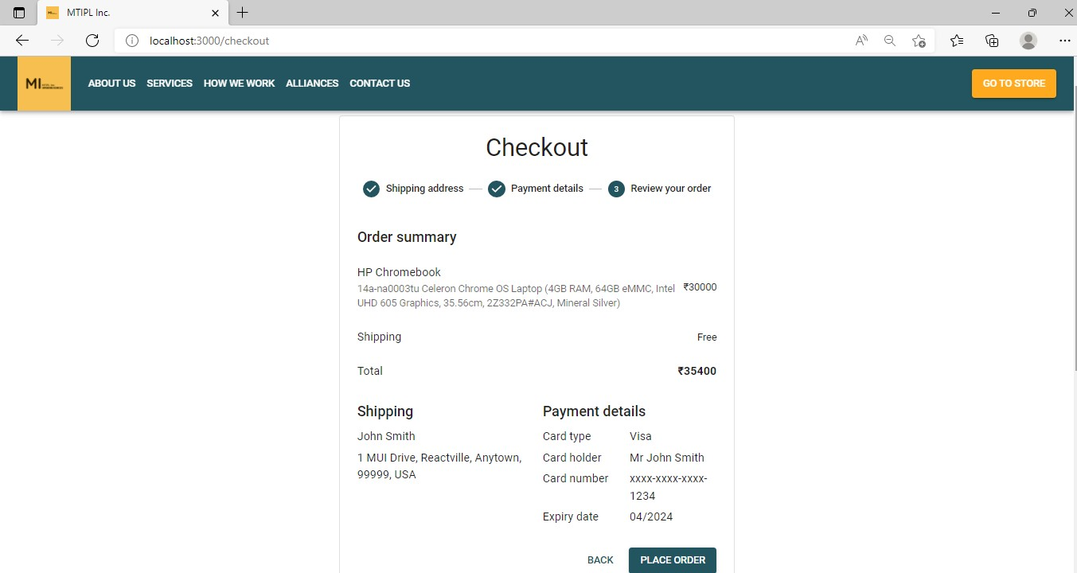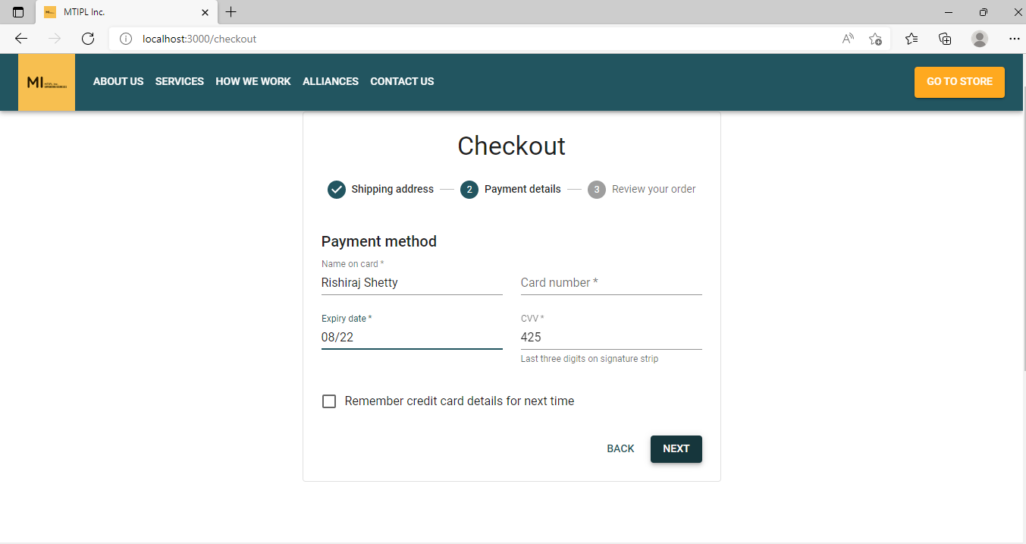

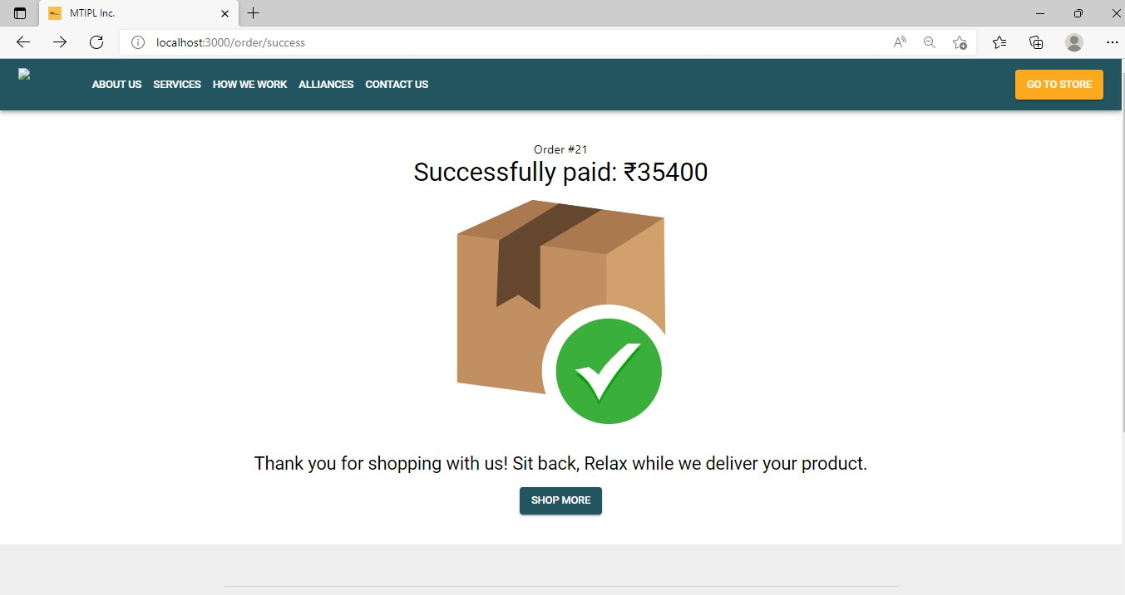

## User Documentation

The website is designed to provide ease of shopping to customers. For running this website user should have iis server installed upon their computer/laptop. . Go to your internet browser and type ―local host://‖ followed by the name of the website you have created. The website contents appear. This is a way to start the website till it goes live. In that case, the user will have to only type the name of the website on his/her search window in the internet browser and the website should open.

## Conclusion

**CHAPTER 7**

**Conclusions**

The Mtipl Inc developed using Java Script fully meets the objectives of the system for which it was developed. The application has reached a steady-state where all bugs have been eliminated. The application is operated at a high level of efficiency and all the teachers and users associated with the system understand its advantage. The system solves the problem it was intended to solve. Admin gets rights for all activities. Once the user has login and select the class and session that he/she has the rights to get all information about the product. Thus he/she enjoy and feel comfort in using the application. Some of the difficulties that faced in the existing system are eradicated and this website provides a user-friendly interface. The system solves the problem it was intended to solve.

The emergence of ecommerce as we know today developed with the emergence of the Internet. Initially, this platform only functioned as an advertising tool for companies, providing information about its products. It quickly moved on from this simple utility to actual online shopping transaction due to the development of interactive Web pages and secure transmissions.

The project Ecommerce Hardware Website is GUI based system so that it is easy to handle. It also increases the efficiency of the end user, because it will reduce the redundant job, which is tedious to complete. The Online System also has automated capability to complete job, so it reduces the work manually. The purpose is to enable the Product Buyers to search for the Products from any remote location.

### Significance Of System

The key features of the system are-

1. This online program will take less time and gives better results.
2. It reduces the tedious jobs Like (Redundant work, long procedures, Up to Date Information).
3. It will improve the online shopping system, since all the information is available whenever required.
4. It provides quick processing thus helps in transaction
5. It provides accurate output.
6. It gives fast answer of queries.
7. The amount of paper work is reduced.
8. Better Control.

The website makes sure about the speedy and flawless operation as per different genres. Such a structure also makes available an option for the admin to collect all the basic details displayed in the database.

## Limitations Of The System

The E-commerce hardware store is in itself a complete system, though it has a few limitations, but it has a lot of future scope and features that could be added to make it more widely acceptable. One limitation is the application is not live it can run on local host or with fake domain for eight hours. Apart from this we need to create a better User interface with interesting gif and animation etc. The application needs a laptop with all software requirements to run.

##### Few more limitations include-

1. This project does not give the information about the stock (quantity) present within the shop.
2. This project does not create monthly, yearly Reports.

After removing these and other minor limitations using latest technologies the website can give swift results. User.

## Future Scope

Notification service

* End users would receive real-time notification updates on new products / services releases
* They would receive push notifications for upcoming discounts and offers. Payment gateway
* End users would have the ability to make real-time payments using a payment gateway like

Razorpay or so, which will support multiple modes of payment (UPI, Bank transfer, etc.) Order tracking

* Users would receive real-time updates on the status of their order requests that will help them be aware of the progress on their requests.

Multiple products other than electronics can be added Return/Exchange facilities within 15 days can be provided to the user.

The system can be made robust by launching it on the app store thus making it easier to use. Cash on Delivery and more payment options can be added.

# References

Beginner to Intermediate PHP5 https://app.diagrams.net/ https[://www](http://www.seminarprojects.com/).[seminarprojects.com/](http://www.seminarprojects.com/) https:/[/www](http://www.tutorialspoint.com/).[tutorialspoint.com](http://www.tutorialspoint.com/) https:/[/www](http://www.google.co.in/).[google.co.in](http://www.google.co.in/) https://en.wikipedia.org https:/[/www](http://www.geeksforgeeks.org/).[geeksforgeeks.org/](http://www.geeksforgeeks.org/)